CS3451 PROJECT 23REPORT

The title: CS3451 Fall 2014, Project3 SPIRAL ANIMATION

Author: Bo Chen

Collaboration statement: Worked with Shen Yang on how it should be designed and the Math behind it.

Project3 SPIRAL ANIMATION:

Implement two different color rectangles, green and red. Both rectangles can be rotated, scaled and moved in the screen. Showing an animation from green rectangle spiraling to the red rectangle.

The movement of rectangles is calculating the vector of centroid and mouse, by changing the centroid of rectangles to make the movement. Using “dragAll();”

The knowledge of rotating the rectangle is calculated by finding the angle of the vector of the rectangle’s centroid，keep tracking the angle’s change, and use “rotateAll()”function.



The scaling is calculating the distance between the mouse and centroid, measure the vector from mouse to centroid. Using “scaleAll();”



The animation of the rectangles movement is using the following formula in 4.11 - 05NA.pdf

P(t) = 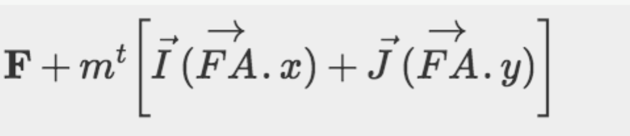

where (I, J) are the basis vectors for rotation (so I =<cos(Θt),sin(Θt)>), and vector FA is the standard for the vector created by A−F. the following equations are calculating the fixed point F, after getting fixed point, we put it into the p(t) formula, and give it a period of time. Tracking the P(t) , these points will give us the animation.

